**Practical 10**

**Aim:** Configure a VLAN using Packet Tracer.

**Virtual LAN:**A Virtual LAN is a group of devices on one or more LANs that are configured to communicate as if they were attached to the same wire, when in fact they are located on a number of different LAN segments. Because VLANs are based on logical instead of physical connections, they are extremely flexible. VLANs is used to control broadcast domain.

**Advantages of VLANs**

**Broadcast Control** – Broadcasts are received by every host on the switched network. In contrast, each VLAN belongs to its own broadcast domain (or IP subnet); thus broadcast traffic from one VLAN will never reach another VLAN.

**Security** – VLANs allow administrators to “logically” separate users and departments.

**Flexibility and Scalability** – VLANs remove the physical boundaries of a network. Users and devices can be added or moved anywhere on the physical network, and yet remain assigned to the same VLAN.

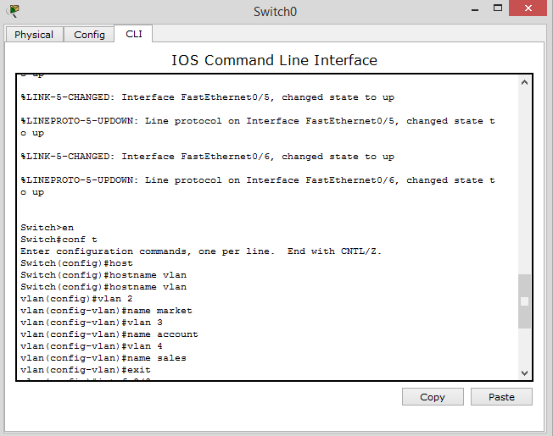

Fig 10.1 Creating Different Vlan

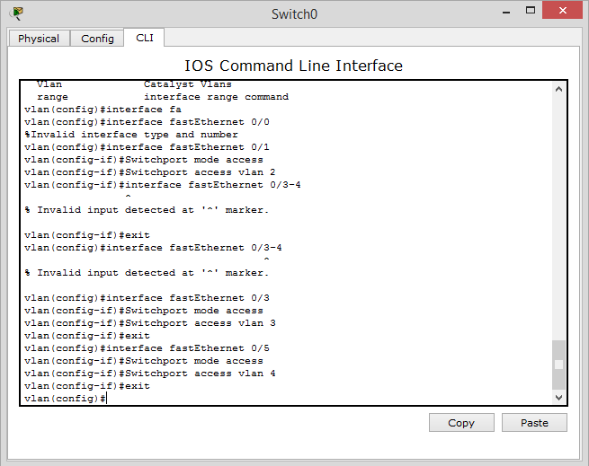

Fig10.2 Adding Ports to different Vlan

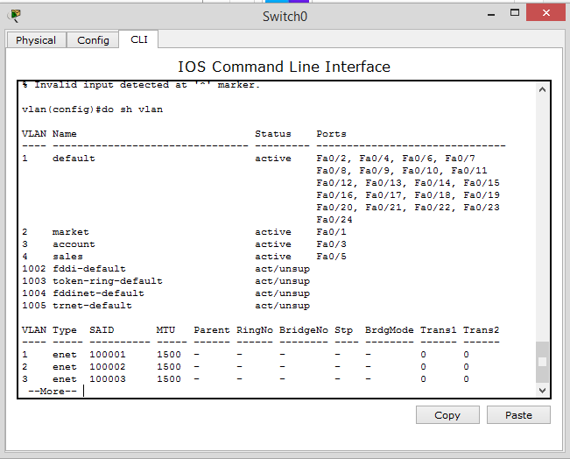

Fig10.3 Showing Different Vlan

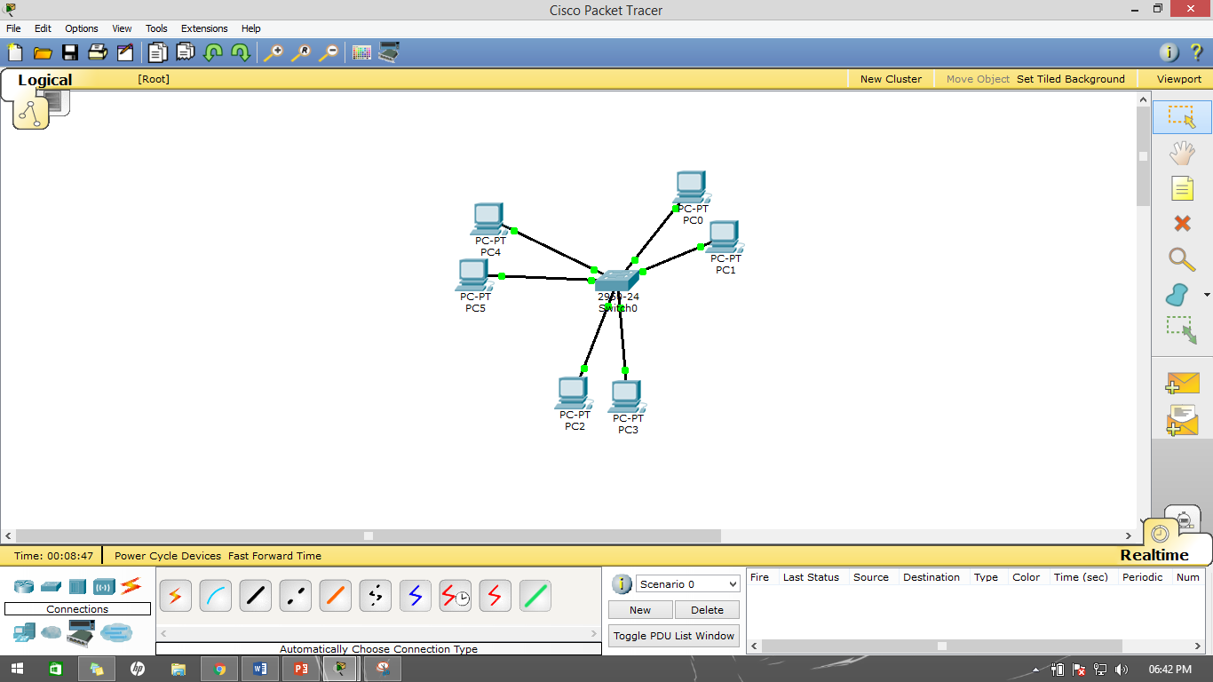

Fif10..4 Network In which VLan Stablized